# Tomcat Installation

1. Download the tomcat zip package and unzip it

#http://tomcat.apache.org/

#unzip apache-tomcat-8.0.24.zip

1. Add the admin user to access the GUI manager

#cd /opt/apache-tomcat-8.0.24/conf/tomcat-users.xml

$TOMCAT_HOME/conf/tomcat-users.xml (Updated)

Xml

<tomcat-users>

<!--

<role rolename="tomcat"/>

<role rolename="role1"/>

<user username="tomcat" password="tomcat" roles="tomcat"/>

<user username="both" password="tomcat" roles="tomcat,role1"/>

<user username="role1" password="tomcat" roles="role1"/>

-->

<role rolename="manager-gui"/>

<user username="admin" password="admin" roles="manager-gui"/>

</tomcat-users>

1. Go to the unzipped dir and start tomcat

#cd /opt/apache-tomcat-8.0.24/bin

#chmod 744 startup.sh

#chmod 744 catalina.sh

# ./startup.sh

1. Log in to console using ip and port number 8080

On RHEL7

#systemctl get-default

#systemctl set-default multi-user.target

1. Install java

#yum install java-1.8.0-openjdk-devel.x86_64

1. Download tomcat

#wget <http://www.trieuvan.com/apache/tomcat/tomcat-8/v8.5.5/bin/apache-tomcat-8.5.5.tar.gz>

<https://www.digitalocean.com/community/tutorials/how-to-install-apache-tomcat-8-on-centos-7>

# Jenkins

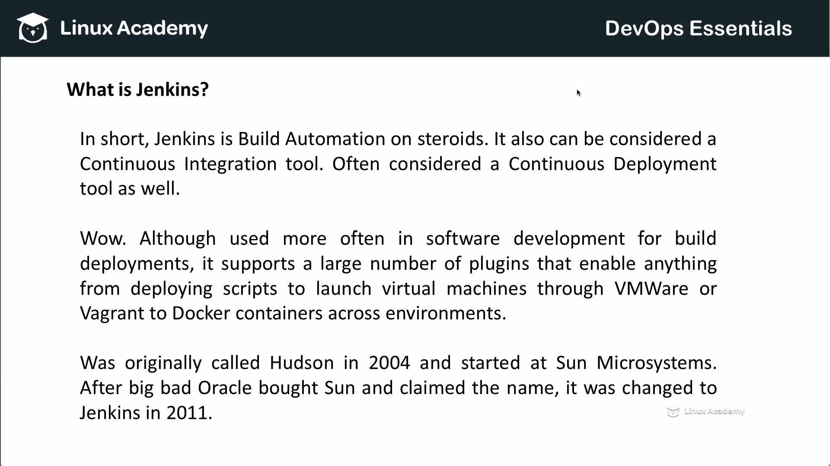

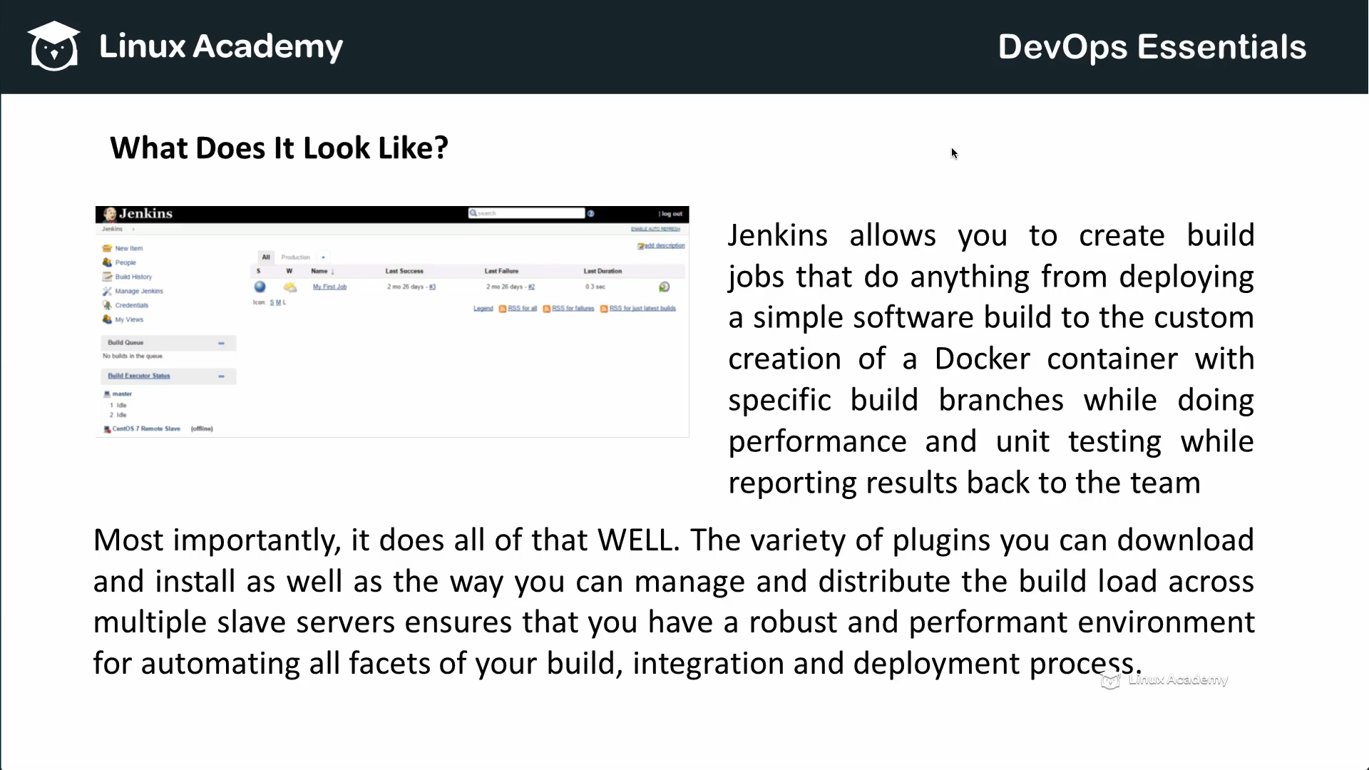

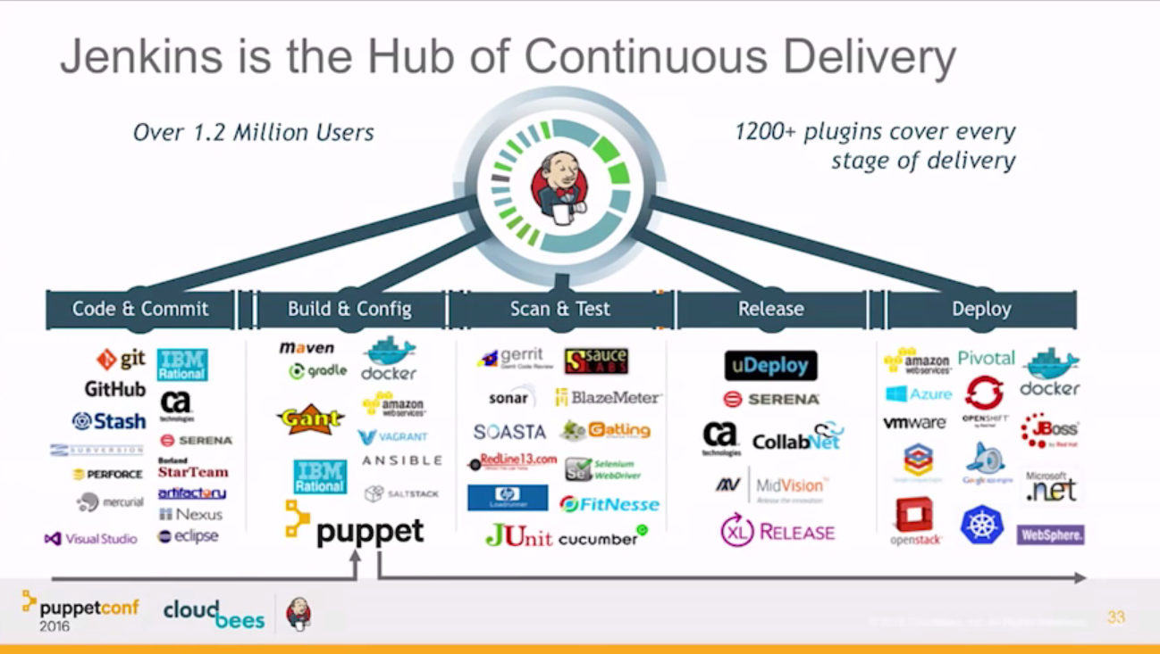

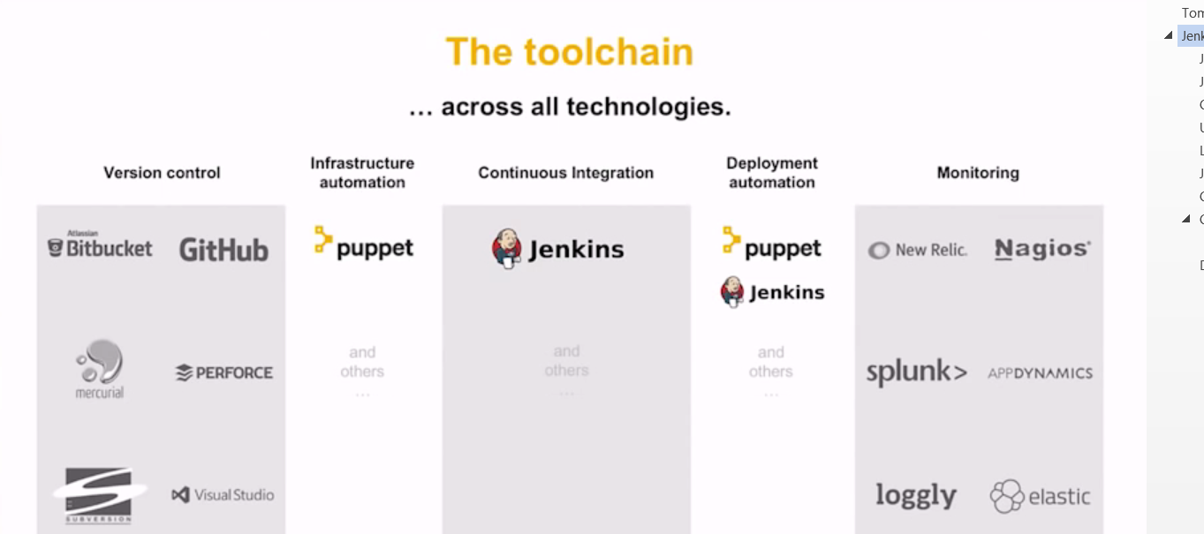

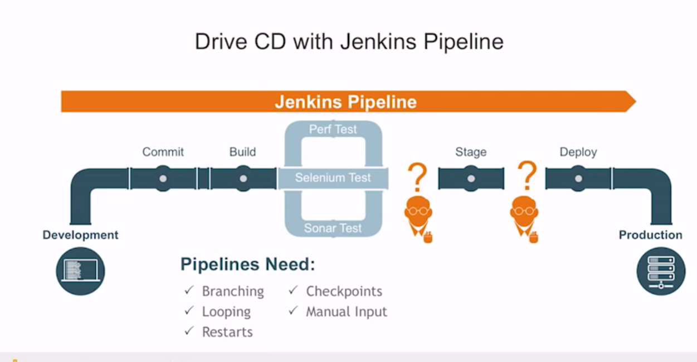

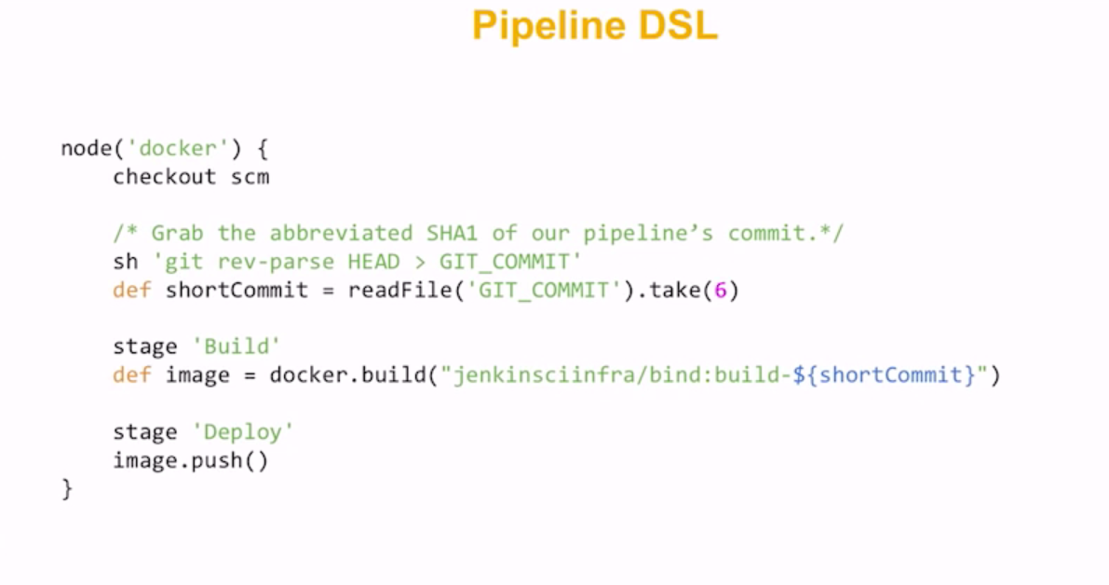

## Jenkins Installation

1. Download Jenkins.war file from <https://jenkins-ci.org/> using tomcat war deployment from tomcat admin console

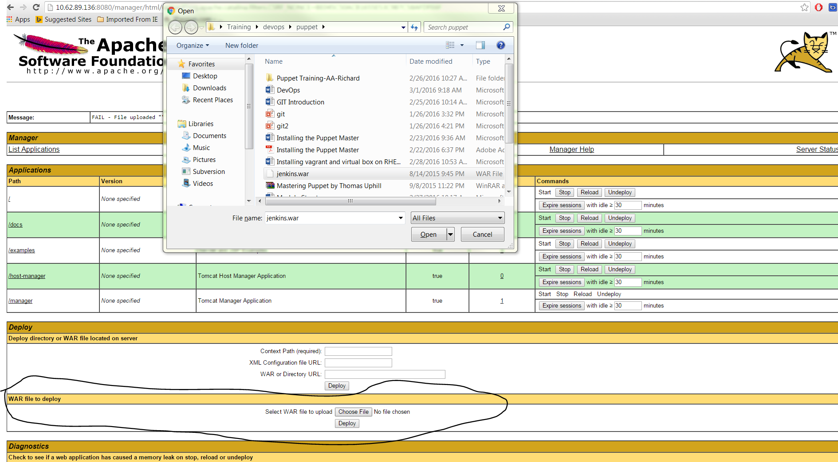

1. You may get error that is because of default file size . change size setting in

#/opt/apache-tomcat-8.0.24//webapps/manager/WEB-INF/web.xml

<multipart-config>

<!-- 50MB max -->

<max-file-size>152428800</max-file-size>

<max-request-size>152428800</max-request-size>

<file-size-threshold>0</file-size-threshold>

</multipart-config>

1. Restart the tomcat and connect to Jenkins app <http://10.62.89.136:8080/jenkins/>

## Jenkins using RPM

# wget -O /etc/yum.repos.d/jenkins.repo <https://pkg.jenkins.io/redhat/jenkins.repo>

# rpm --import https://pkg.jenkins.io/redhat/jenkins.io.key

#yum install jenkins

#systemctl start jenkins

#systemctl enable Jenkins

#rpm -qa | grep jenkins

jenkins-2.25-1.1.noarch

#systemctl stop firewalld

#systemctl disable firewalld

## Cloudbees Jenkins

#sudo wget -O /etc/yum.repos.d/jenkins.repo <http://nectar-downloads.cloudbees.com/nectar/rpm/jenkins.repo>

#sudo rpm --import <http://nectar-downloads.cloudbees.com/nectar/rpm/cloudbees.com.key>

# yum install Jenkins

## Uninstall components

Following components have licensing requirements.

If you do not have an existing license for CloudBees Jenkins Enterprise then all of these must be uninstalled to remove the requirement for licensing.

If you already have an existing license for CloudBees Jenkins Enterprise then the selected components indicate those incompatible with your current license.

CloudBees License Manager

CloudBees Jenkins Enterprise License Entitlement Check

CloudBees Bitbucket Cloud Branch Source Plugin

CloudBees Skip Next Build Plugin

Operations Center Context

CloudBees Amazon Web Services Credentials Plugin

Operations Center Client Plugin

CloudBees Back-up Plugin

CloudBees Folders Plus Plugin

CloudBees Pull Request Builder for GitHub

Operations Center Agent

Operations Center Cloud

CloudBees WikiText Security Plugin

CloudBees Monitoring Plugin

CloudBees Git Validated Merge Plugin

Operations Center Analytics Reporter

CloudBees Role-Based Access Control Plugin

Operations Center Op

## Login to Jenkins

Open your browser and type your server ip and tomcat port http://192.168.1.73:8080/jenkins/

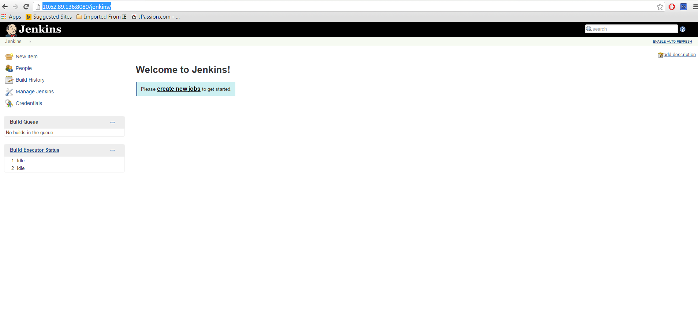

## Jenkins plugin instllation for Git

Manage Jenkins 🡪 manage plugins 🡪 available.

Search for github plugin and install it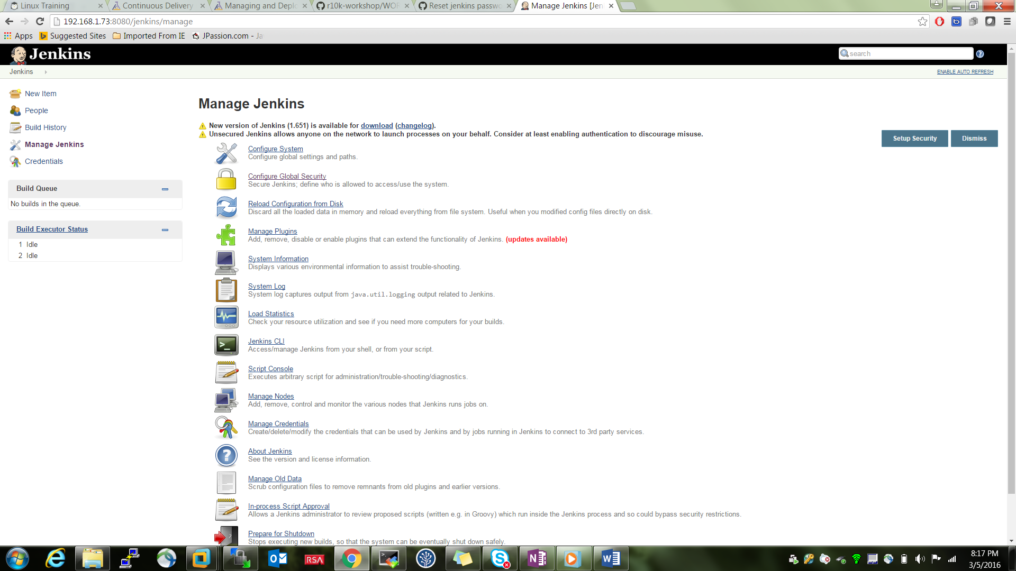

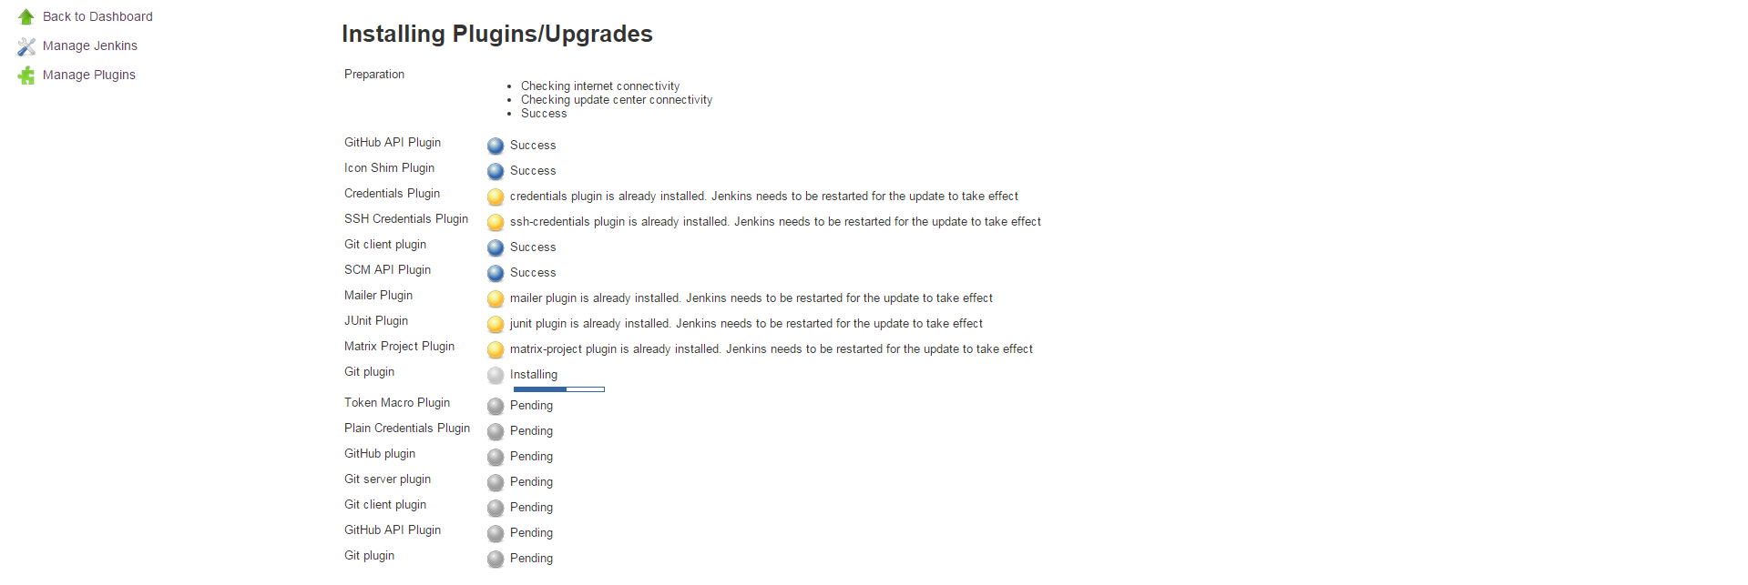

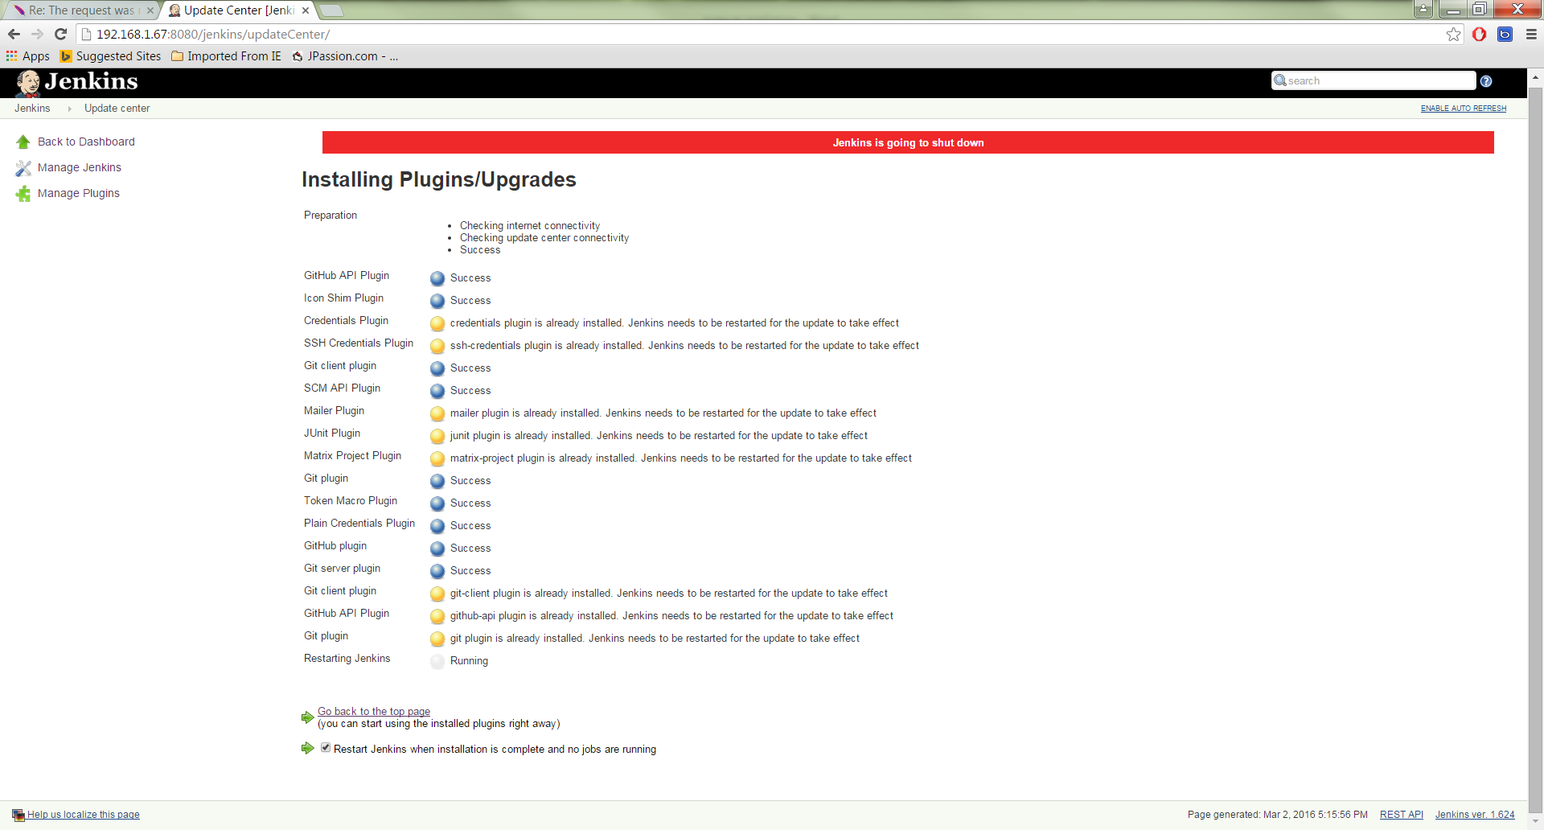

Restart the Jenkins by clicking restart Jenkins.

## Create Jenkins users

Manage Jenkins 🡪 configure Global security 🡪 Jenkins own user database🡪 Save

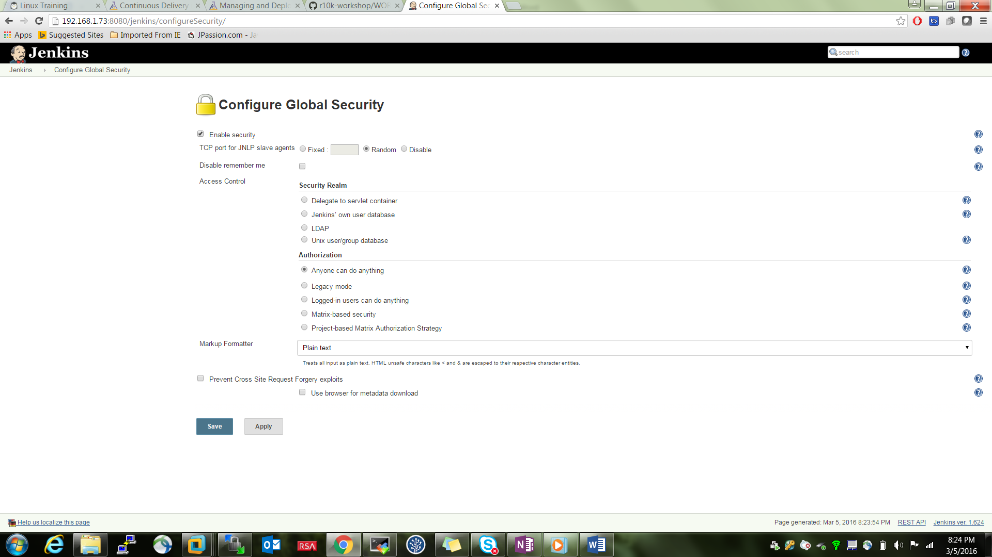

Creating a Job or a project

New items 🡪 free style project

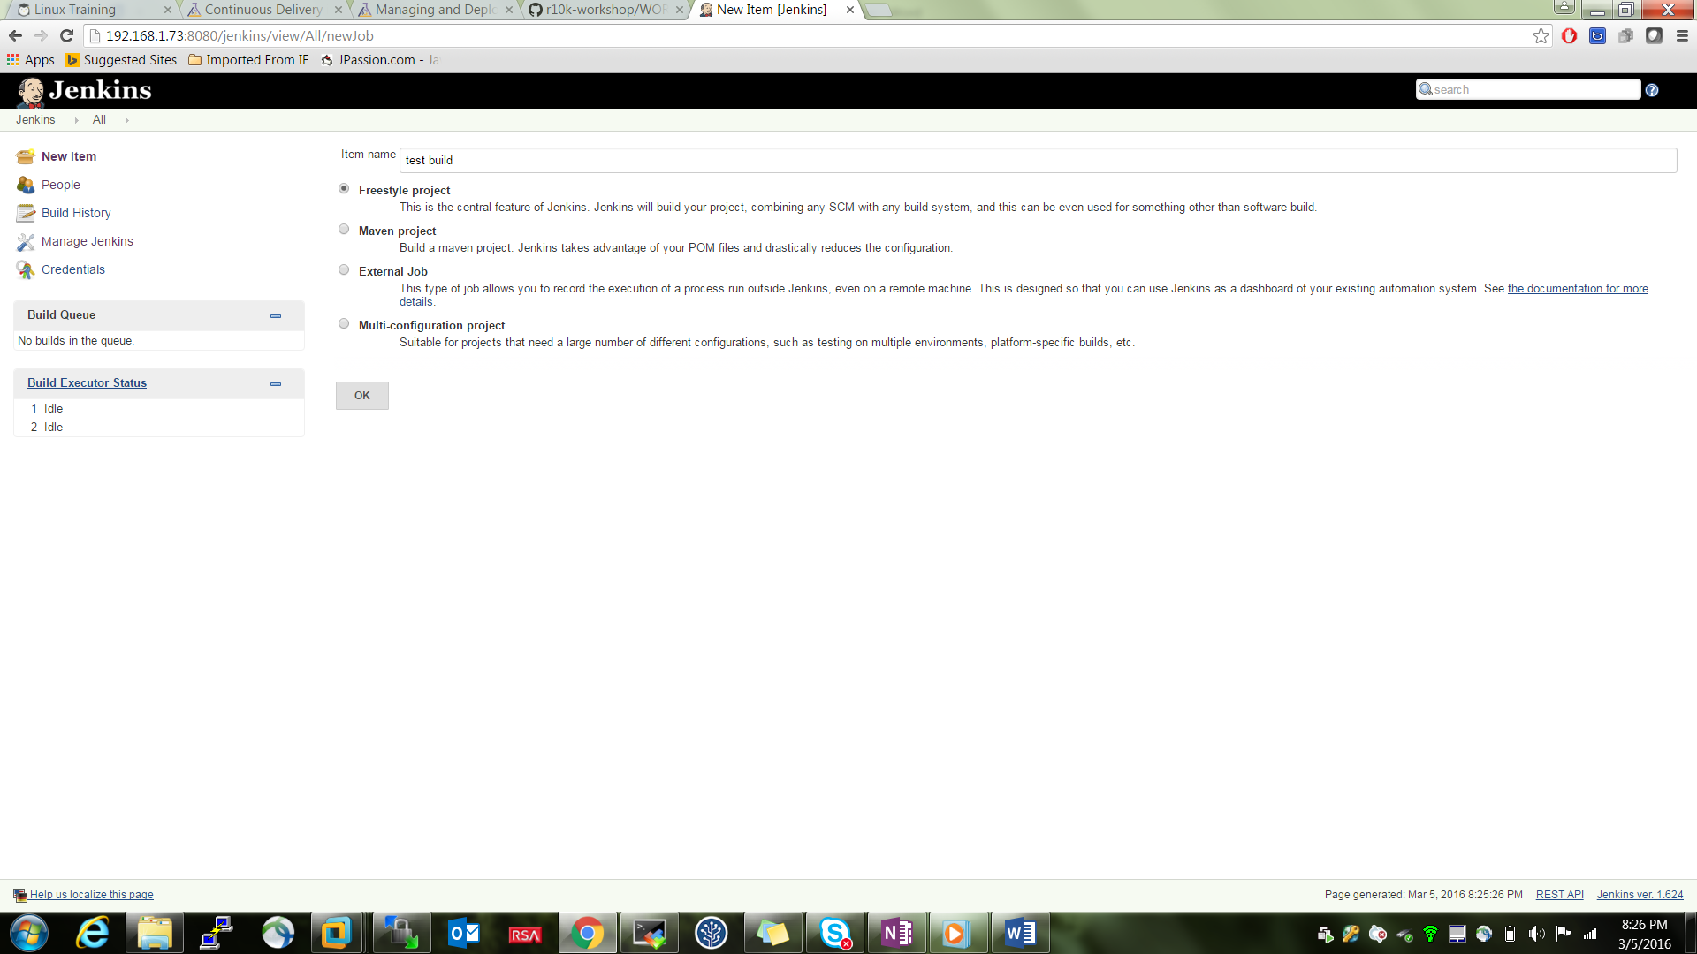

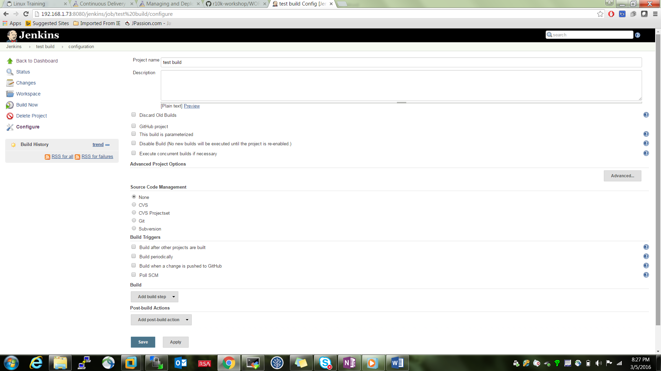

## Cloudbees Jenkins Enterprise Installation

Installing JRE

sudo wget --no-cookies --no-check-certificate --header \

"Cookie: gpw_e24=http%3A%2F%2Fwww.oracle.com%2F; oraclelicense=accept-securebackup-cookie" \

"http://download.oracle.com/otn-pub/java/jdk/8u45-b14/server-jre-8u45-linux-x64.tar.gz"

sudo tar xvf server-jre-8u45-linux-x64.tar.gz

sudo chown -R root: jdk1.8.0_45

create sym links

alternatives --install /usr/bin/java java /opt/apps/jdk1.8.0_45/bin/java 1

alternatives --install /usr/bin/jar jar /opt/apps/jdk1.8.0_45/bin/jar 1

### Installing on Red Hat, CentOS, or Fedora

On Fedora-based distributions, such as CentOS, you can install CloudBees Jenkins Enterprise through yum or dnf(starting with Fedora 23) [[1](https://go.cloudbees.com/docs/cloudbees-documentation/cje-install-guide/chapter-introduction.html#_footnote_1)]. You must install JRE before installing CloudBees Jenkins Enterprise. Oracle 8 JRE is recommended for Linux operating systems. Follow the instructions described under [Installing JRE](https://go.cloudbees.com/docs/cloudbees-documentation/cje-install-guide/chapter-introduction.html#nectar-install-jre).

Before installing CloudBees Jenkins Enterprise, add the CJE repository and the key:

1. First add the repository:

|  |  |
| --- | --- |
| Note | The key & repo refer to the latest version of CJE. To install a specific version refer [here](http://nectar-downloads.cloudbees.com/jenkins-enterprise/) |

1. sudo wget -O /etc/yum.repos.d/jenkins.repo http://nectar-downloads.cloudbees.com/nectar/rpm/jenkins.repo
2. Then, add the key:

sudo rpm --import http://nectar-downloads.cloudbees.com/nectar/rpm/cloudbees.com.key

1. Update yum cache before installing CJE:

|  |  |
| --- | --- |
| Note | The binaries produced after January 2016 are signed with a different Key from those produced prior to this date. If you imported the key prior to this date, the key will need to be re-imported. |

1. sudo yum update
2. Install CloudBees Jenkins Enterprise:

sudo yum install jenkins

The installation process has started CJE.

* In general, to start/stop CJE, simply execute these commands:
* sudo service jenkins start

sudo service jenkins stop

* The log file is located at /var/log/jenkins/jenkins.log
* By default, CloudBees Jenkins Enterprise starts on port 8080. To access CJE point your favorite browser tohttp://(hostname or ip):8080/

## Jenkins pipeline

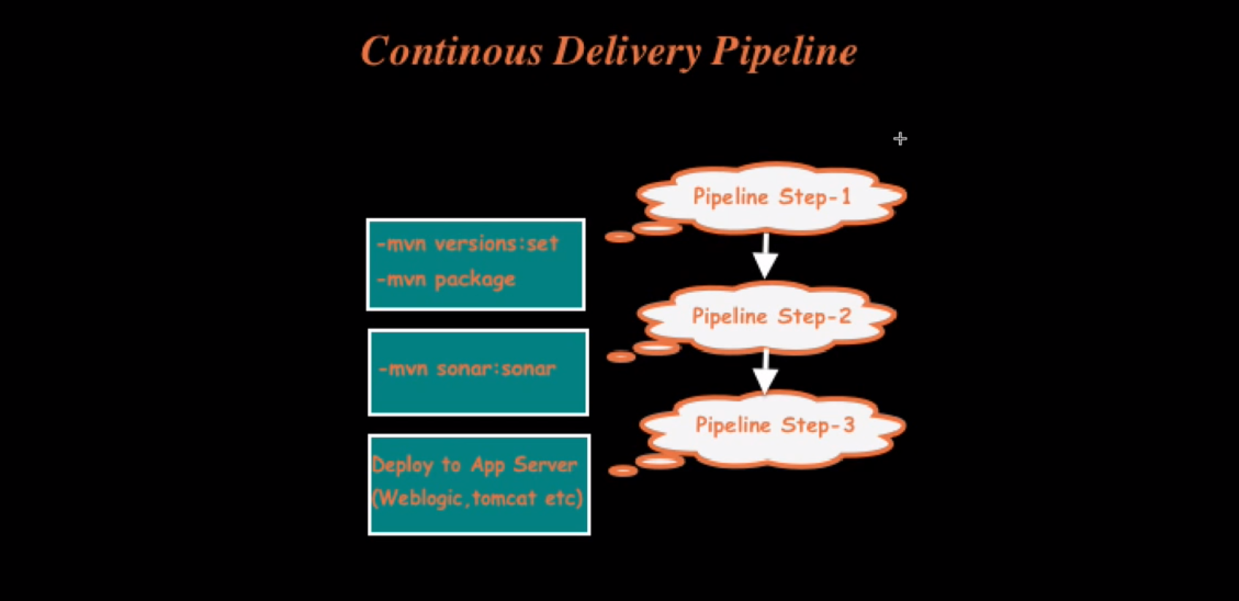

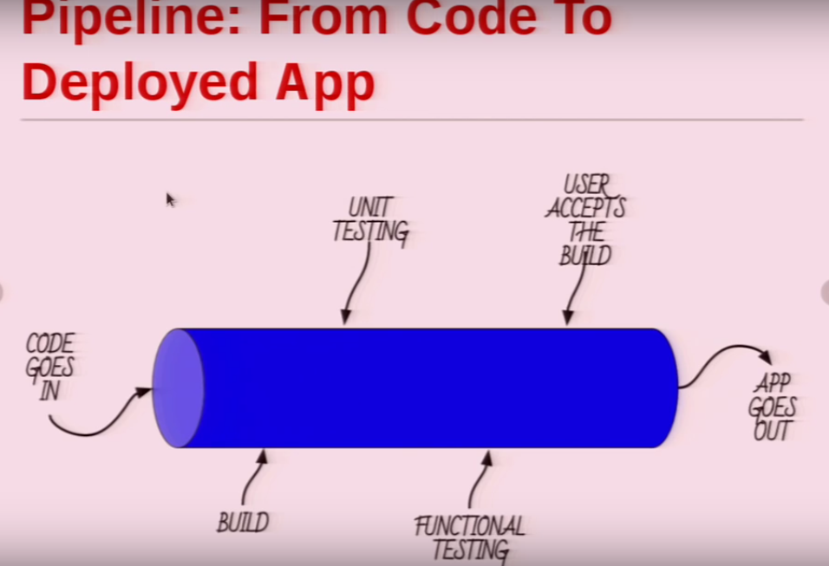

## Docker Jenkins slave

